**MFE Practical Work 2**

**Section 1: Characterizing the four moments across sampling frequency and asset class**

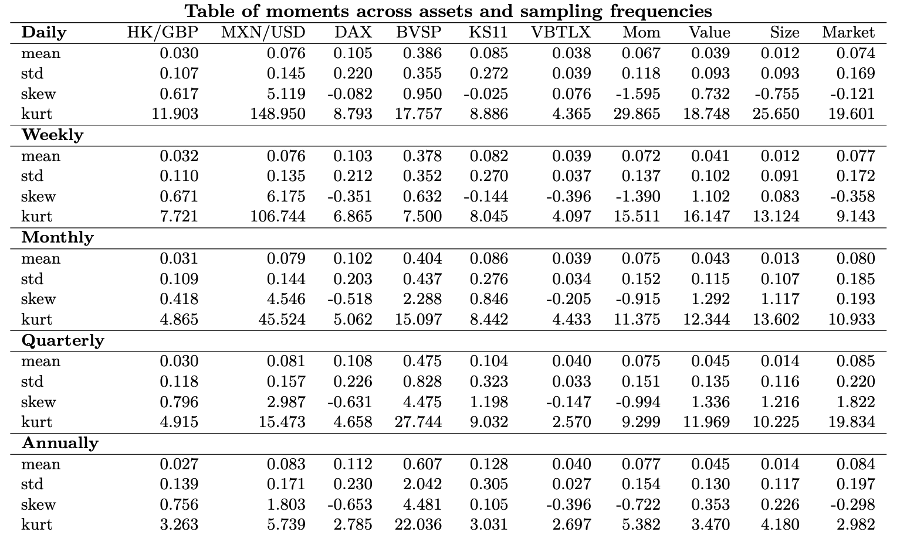

There is a correlation across asset classes between mean and standard deviation. Asset classes with higher mean returns tend to be associated with a higher return variance. This can be most clearly seen when comparing stock returns, such as the DAX and KS11, with bond returns (VBTLX). The stock indices return 10-12\% annually, 5-7% higher than bonds, but come with a standard deviation almost ten times higher. This phenomenon is known as a 'risk premium’ and is conventionally characterized in models such as the CAPM, stating that asset prices (and therefore their returns) are intrinsically linked to their risk.

This effect is seen across asset classes, even in currency and factor price data, both of which have very different characteristic features and behavioural patterns to each other and to the more conventional stock and bond indices. When comparing between our different sampling frequencies we again see the risk premium evident in the data - this makes sense, that inherently riskier assets are more volatile over all time periods. It would be unusual to see an asset that varied relatively greatly day to day, but relatively little over long horizons. If such an asset existed and we had confidence in the data, we could simply buy the asset when the price fell sharply and sell when the price rose sharply (on a daily basis), confident in the knowledge that the asset would likely return to a sampled mean with low variance over time. This 'time arbitrage' would then dampen the noise in the daily data, thus lowering the daily variance to reflect the asset's long-term relative stability.

It is also key to note here that the mean return differs across sampling periods as the arithmetic mean has been taken, instead of the geometric mean that would return the same annualised mean over the different sampling frequencies. In general, the arithmetic mean will return higher means at the annualised daily frequency when the asset price growth is lower and vice versa. For example, take BSVP and the VBTLX indices. However, the way this result behaves is not standardised or easily predictable, so should not be used as a reliable characterisation of the data.

In general, standard deviation rises as the sampling frequency is decreased, largely because we will have fewer data points, and therefore our estimates will be less precise. This effect is quite small, especially small when comparing across daily, weekly, and monthly data perhaps because at this point, we have sufficient data to make reliable estimates. An average of 30 years of monthly data is 360 data points, enough to give some credence and stability whereas the annual data will only have those 30 points, making our estimates less reliable and causing our estimated variance to spike.

Our data exhibits remarkable kurtosis at high sampling frequencies, suggesting heavy tails at a daily frequency, with notably high magnitude in currency and factor price data. This implies that the data has a high number of outliers to the usual volatility - or in other words a high frequency of large daily price movements. The skew at this sampling frequency is also generally negative across classes, suggesting that markets will have many slightly good days, and then a few very bad days. Markets could be negatively skewed because of investor sentiment and human behaviour - investors generally fear losing money and will react quickly to negative information, leading to sharp selloffs, increasing the amplitude of negative slides in prices. This also increases the volatility when prices fall, another factor that could be increasing the magnitude of the skew (It is important to note that this is not ubiquitous, BVSP and the value weighted portfolio have positive skew here which we will return to later).

The kurtosis also falls significantly as we decrease the sampling frequency. This suggests that the high frequency of large daily/weekly price movements characterized earlier cancel each other out over time. It is much less likely that an asset will experience large swings over a significant period of time that are outside it's normal level of volatility, although examples of the Great Financial Crash and coronavirus show it is possible. Notably the kurtosis of several asset classes looks to be approaching 3 as we increase the sampling time period to an annual basis - a kurtosis of 3 being characteristic of a normal distribution. This is of course not to say the financial data is normally distributed, with not insignificant skew we can see this is not the case, but our distributions do start to display some normalised characteristics, with substantially lighter tail risks over this time horizon.

There are also some substantial differences in the four moments and thus the behaviour of the underlying asset classes relative to each other.

For example, the two currencies exhibit rather differing characteristics, the Mexican peso is very highly skewed, with a similarly high kurtosis (relative to USD) whereas the Hong Kong dollar is far less prone to price shifts outside its normal implied range. This is likely due to the underlying macro effects that underpin these currencies - Mexico has been subject to considerably more economic and political stress over the time period, and relations with the US, its biggest trading partner, have also been volatile. This might explain some of the extremity of its data - the currency is prone to rapid devaluation at the onset of tensions, far more so than Hong Kong. Hong Kong in fact has a currency peg with the USD, so the HK/GBP rate will be largely characteristic of the USD/GBP relationship - this explains a great deal of the currency's relative stability compared to the peso. Overall it is hard to draw concrete conclusions from two examples, but a conjecture can be made that currencies don't have any one characteristic distribution, but instead are reflective of the macroeconomic factors that underpin them, such as interest rates, pegs, and international/economic tensions.

The Brazilian stock index behaves differently to the other indices, and in fact the other asset classes, most notably showing increases in skew and kurtosis at the annual frequency compared to daily with a relatively large increase in variance and exhibiting an odd fall in kurtosis at the weekly level. Not all of this variation can be easily explained, but the index looks to be behaving in a more volatile, less normalised fashion at longer time horizons, which could be indicative of underling macroeconomic effects. Brazil is an emerging nation that has grown very sharply in the past few decades, additionally being hit sharply by economic shocks (e.g. in 2008), so this argument holds weight. In comparison, A nation like Germany (for the DAX) will have been more stable, with returns starting to distribute in a normalised fashion around the mean (while still displaying the characteristic negative skew).

The factor prices are especially interesting, with the Momentum factor exhibiting significant negative skew with high kurtosis This indicates that this strategy is exposed to sizeable negative swings relative to their volatility, although the weight of the data in the tails does fall as the sampling frequency decreases, again suggesting that these short-term price swings tend to eventually cancel out. It is possible that momentum has such a high tail risk because it will be subject to bubble patterns - sharply rising stocks will be bought, and falling stocks sold - this leaves a great deal of exposure to a bubble bursting, giving an asymmetric distribution of returns as observed.

**Section 2: Comparing across subsamples**

**Figure 1: Risk premia by decade**

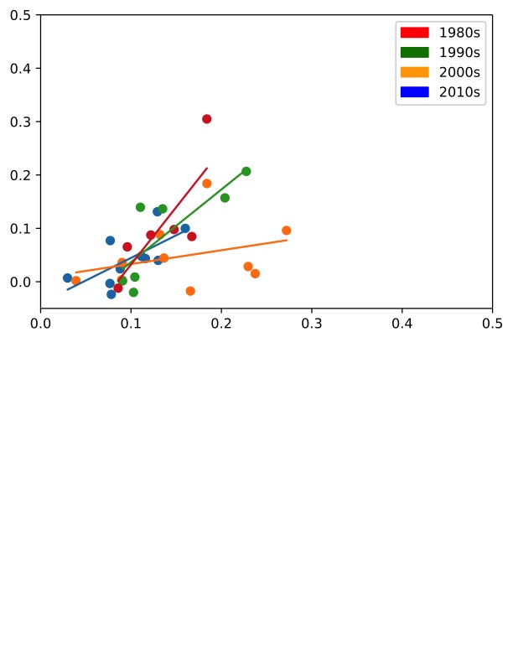

The graph above plots mean return (y axis) on the standard deviation for each asset class, with each colour denoting a specific decade. A line of best fit has also been added to each decade to show a general relationship of the risk premium.

While this data is quite variable, and some data points have been removed due to lack of data, there is a curious shift of the relationship between risk and reward. The orange line (for the 2000s) is very low, largely due to the residual impact of the financial crash in 2008, but together with the blue line of the 2010s there does look to have been a flattening of the relationship from 1980 to the present day. If true, this would imply that the risk premium, the reward for accepting a higher level of volatility in an asset, has been steadily falling over time. This is an interesting conjecture but would require a much more in-depth analysis to draw firm conclusions. As we can see below, returns especially from the stock indices and the momentum and size factors was much greater in the 1980-2000 period. Potentially it may be the case that returns have just not been as strong as the 80s and 90s due to the impact of the financial crash in the 2000s decade, and stagnant growth following this in the 2010s, but equally this could be representative of a macroeconomic slowdown in growth in the economies reflected. Either assertion would require a much more complete analysis with comparisons to faster growing economies also affected by the financial crash and subsequent conditions.

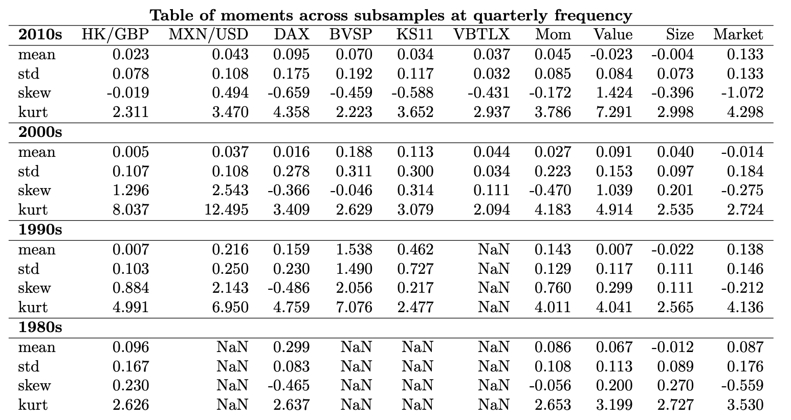

Focusing in on stock returns over the period, a notable case is the Brazilian stock index (BVSP). The index had a remarkable 153% annualised return in the 1990s, with a heavily positive skew most likely caused by years of surging growth. Brazil underwent significant growth in this period (enough to be segmented into a group of fast-growing emerging economies in the 2000s, the BRIC’s), and subsequent decades show moments much closer to the other indices, DAX and KS11. Furthermore, this supports the hypothesis proposed earlier, that BVSP’s positive skew and heavy kurtosis exhibited at decreased sampling frequency was driven by years of intense macroeconomic growth. One could also expect that if stock index data was taken only from the year 2000 that BVSP would behave much like the DAX and KS11 indices, and thus one would be able draw an underlying characteristic distribution of stock indices that would accurately describe indices of developed markets. This arguments rests on the assumption that relatively developed market indices are subject to similar underlying economic forces and price movements, and thus can be similarly characterized. Supporting this analysis is the fact that the market factor has very similar characteristics to the shown stock indices in the last 2 decades (a factor that tracks the US stock market excess return above the risk-free rate).

At the subsampled level there is also additional information on the momentum price factor.

**Section 3: Estimating degrees of freedom parameters for a student’s t distribution across sampling frequencies and asset class**

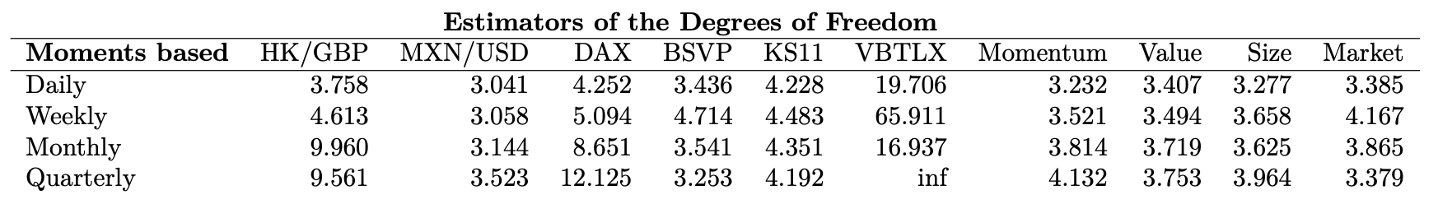

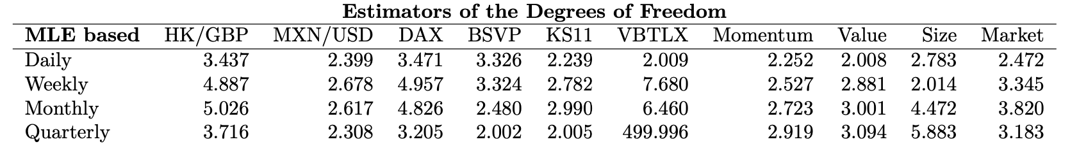

Low degrees of freedom mean more weight in the tail

Higher degrees of freedom mean our data displays more normalised characteristics, with a bell curve shape and lighter tails – this would make this asset class more predictable over the time period